**Philippine Map**

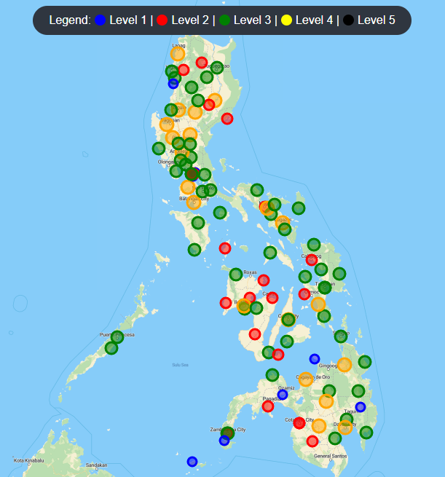

**REGIONS (Total SUC):**

Region I – Ilocos Region (6)

CAR – Cordillera Administrative Region (6)

Region II – Cagayan Valley (5)

Region III – Central Luzon (11)

NCR – National Capital Region (7)

Region IV‑A – CALABARZON (5)

Region IV-B – MIMAROPA Region (6)

Region V – Bicol Region (9)

Region VI – Western Visayas (7)

Region VII – Central Visayas (4)

Region VIII – Eastern Visayas (10)

Region IX – Zamboanga Peninsula (6)

Region X – Northern Mindanao (5)

Region XI – Davao Region (5)

Region XII – SOCCSKSARGEN (2)

Region XIII – Caraga (4)

BARMM – Bangsamoro Autonomous Region in Muslim Mindanao (4)

NIR – Negros Island Region (4)

Total SUC: 106

I**locos Region (Region I)**

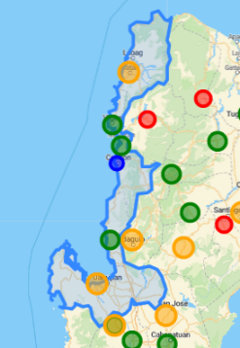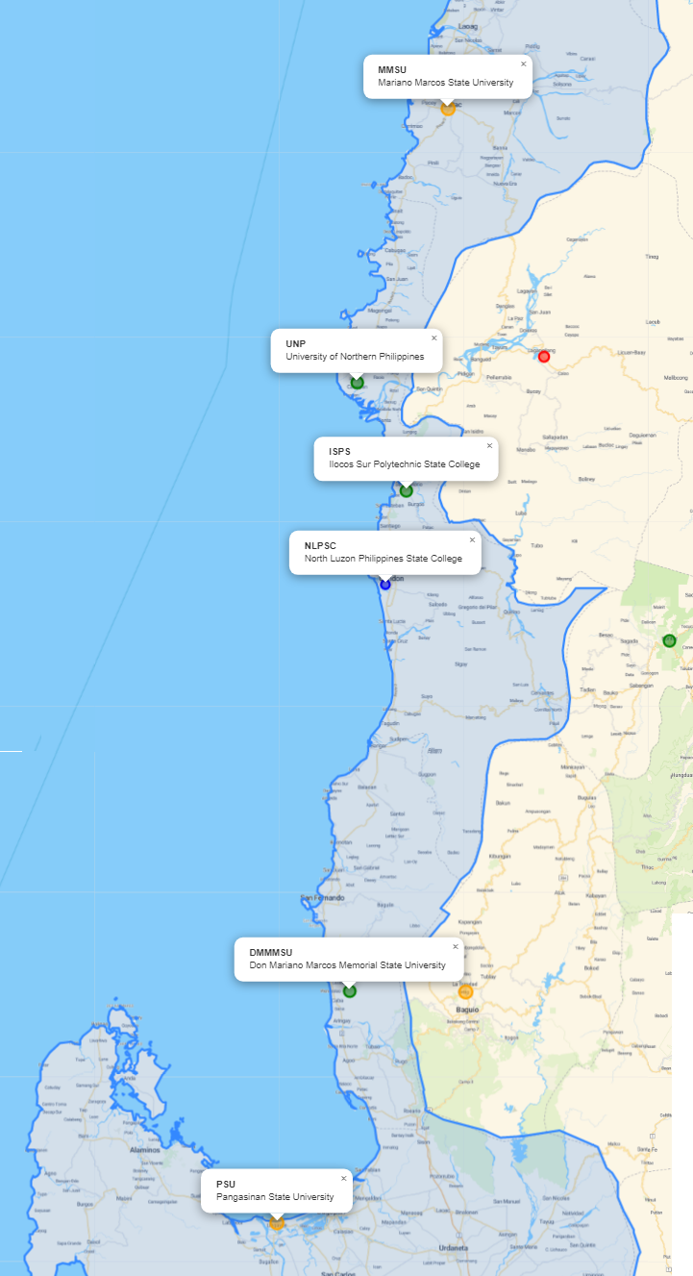

SUC:

1. Ilocos Sur Polytechnic State College (17.3652, 120.4757)
2. Mariano Marcos State University (18.0582, 120.5559)
3. University of Northern Philippines (17.5612, 120.3827)
4. North Luzon Philippines State College (17.1940, 120.4367)
5. Don Mariano Marcos Memorial State University (16.4563, 120.3695)
6. Pangasinan State University (16.0322, 120.2297)

**Cordillera Administrative Region (CAR)**

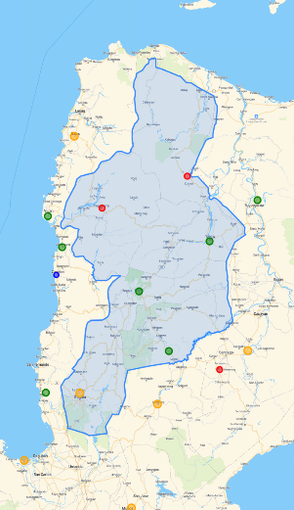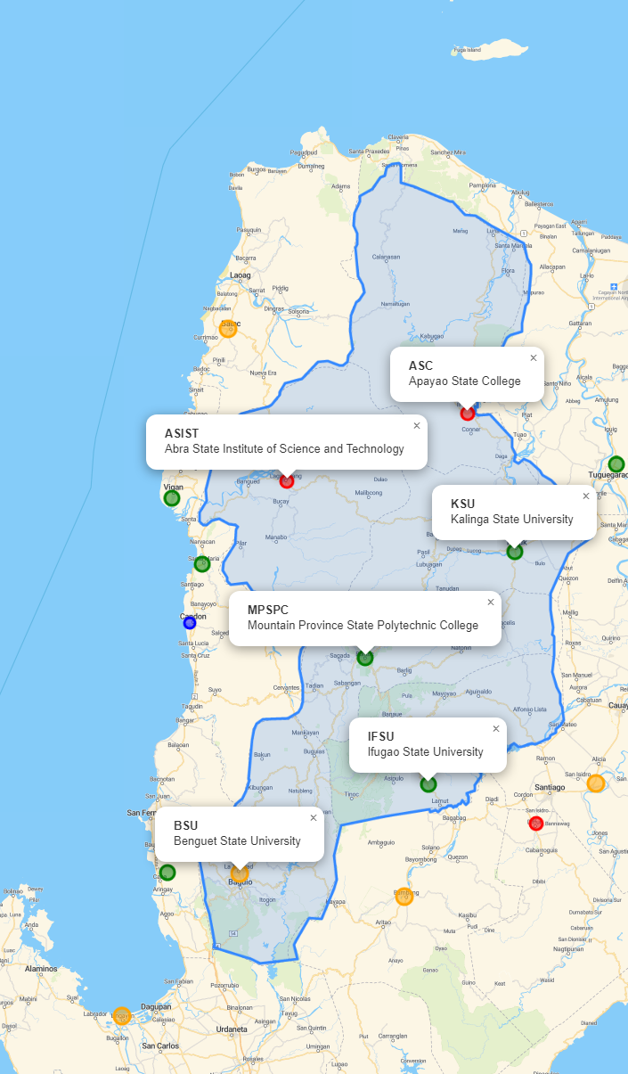

SUC:

1. Apayao State College (17.8087, 121.2946)
2. Abra State Institute of Science and Technology (17.6090, 120.7380)
3. Kalinga State University (17.4025, 121.4406)
4. Mountain Province State Polytechnic College (17.0916, 120.9779)
5. Ifugao State University (16.7176, 121.1726)
6. Benguet State University (16.4544, 120.5903)

**Cagayan Valley (Region II)**

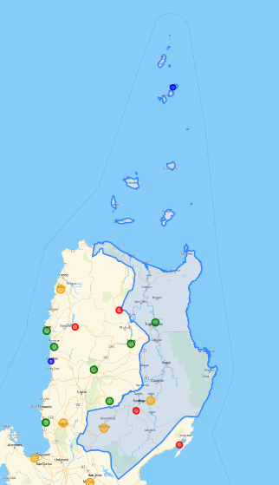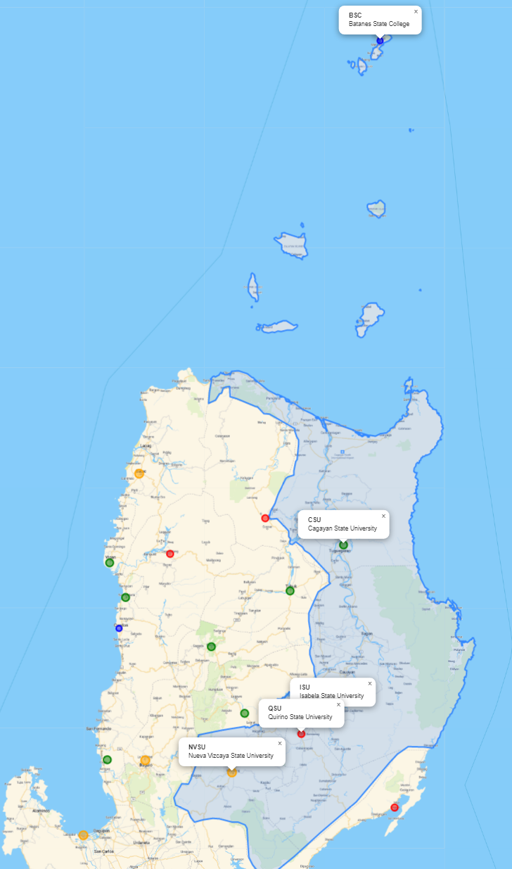

SUC:

1. Batanes State College (20.4511, 121.9686)
2. Cagayan State University (17.6607, 121.7525)
3. Isabela State University (16.7212, 121.6887)
4. Quirino State University (16.7212, 121.6887)
5. Nueva Vizcaya State University (16.3871, 121.1003)

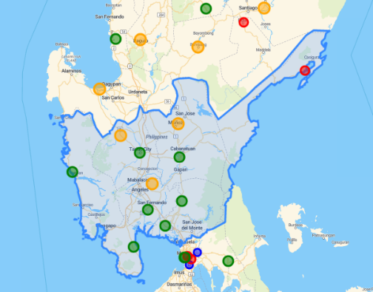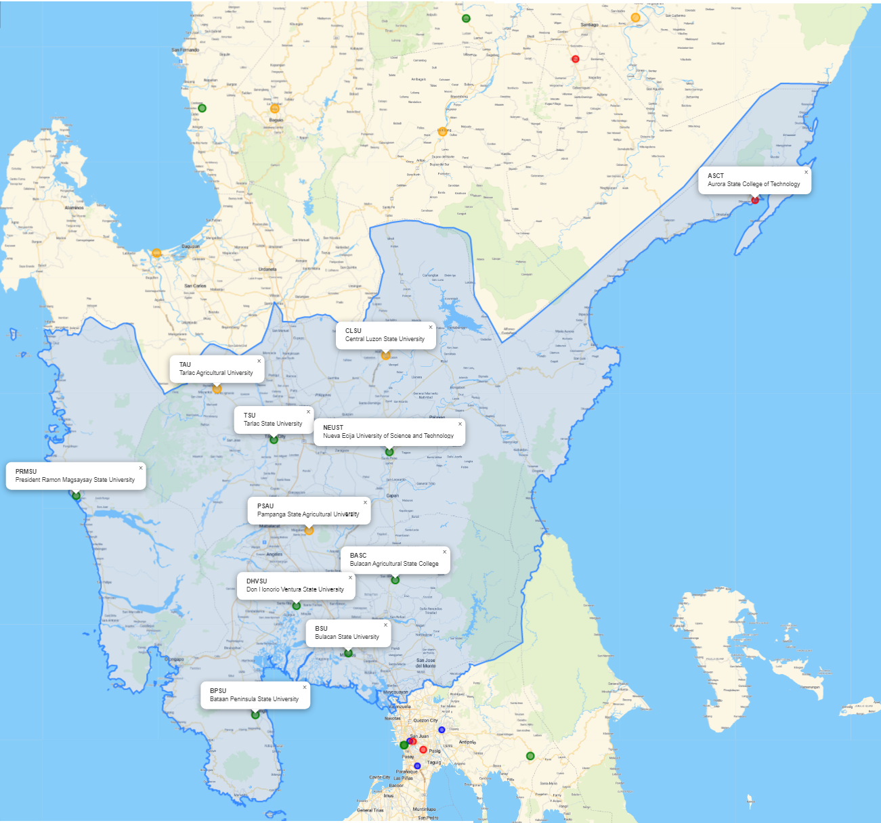**Central Luzon (Region III)**

SUC:

1. Aurora State College of Technology (16.1889, 122.0523)
2. Central Luzon State University (15.7334, 120.9283)
3. Tarlac Agricultural University (15.6346, 120.4144)
4. Tarlac State University (15.4854, 120.5868)
5. Nueva Ecija University of Science and Technology (15.4494, 120.9391)
6. President Ramon Magsaysay State University (15.6346, 120.4144)
7. Pampanga State Agricultural University (15.2190, 120.6949)
8. Bulacan Agricultural State College (15.0731, 120.9570)
9. Don Honorio Ventura State University (14.9978, 120.6560)
10. Bulacan State University (14.8579, 120.8137)
11. Bataan Peninsula State University (14.6769, 120.5306)

**National Capital Region (NCR)**

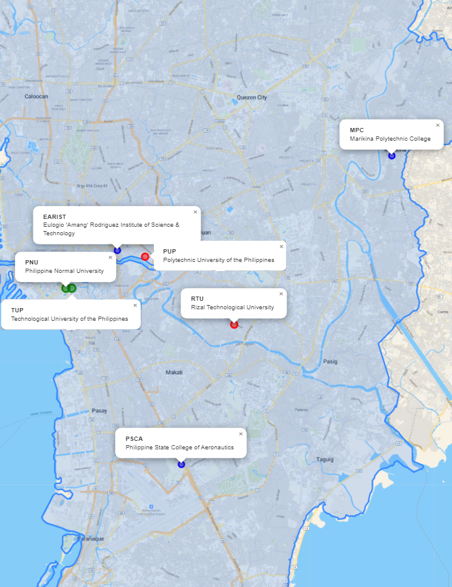

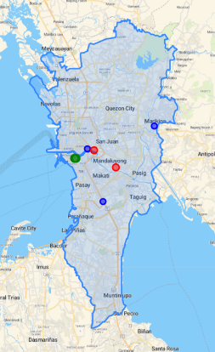

SUC:

1. Marikina Polytechnic College (14.6324, 121.0982)
2. Eulogio “Amang” Rodriguez Institute of Science & Technology (14.6001, 121.0011)
3. Polytechnic University of the Philippines (14.5979, 121.0108)
4. Philippine Normal University (14.5871, 120.9828)
5. Technological University of the Philippines (14.5870, 120.9848)
6. Rizal Technological University (14.5746, 121.0423)
7. Philippine State College of Aeronautics (14.5267, 121.0237)

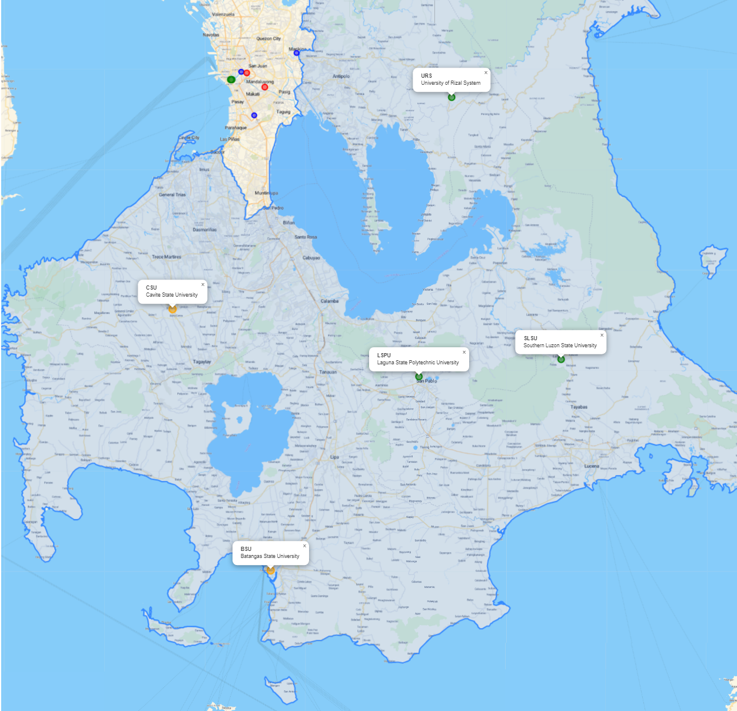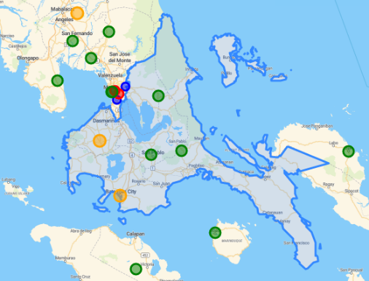**CALABARZON (Region IV-A)**

SUC:

1. University of Rizal System (14.5567, 121.3692)
2. Cavite State University (14.1978, 120.8815)
3. Southern Luzon State University (14.1127, 121.5612)
4. Laguna State Polytechnic University (14.0831, 121.3122)
5. Batangas State University (13.7543, 121.0530)

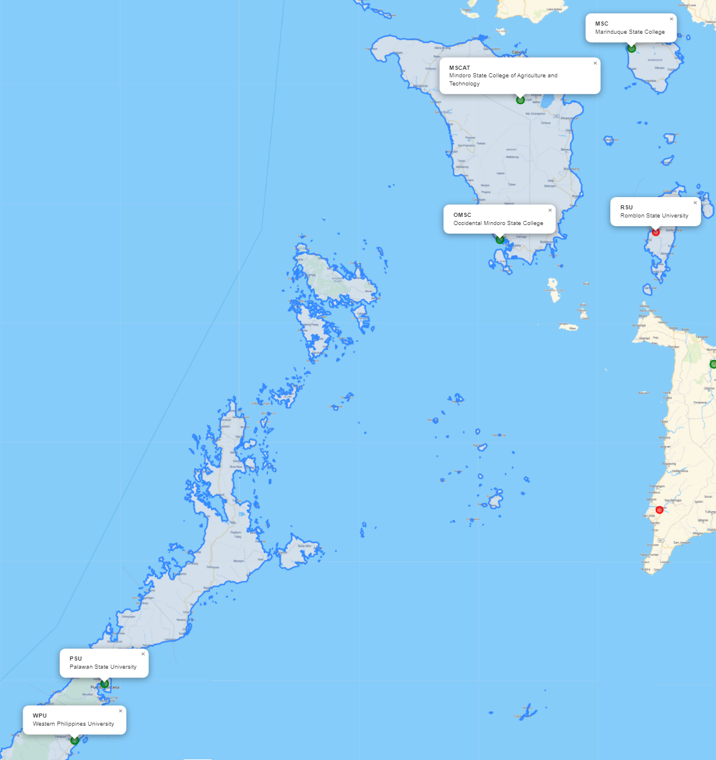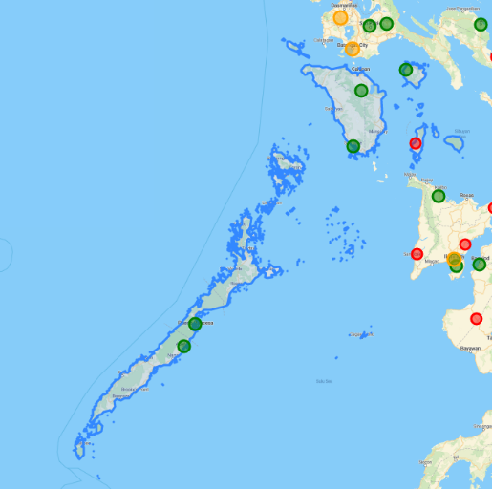**MIMAROPA (Region IV-B)**

SUC:

1. Marinduque State College (13.4530, 121.8447)
2. Mindoro State College of Agriculture and Technology ()
3. Romblon State University (12.3964, 121.9878)
4. Occidental Mindoro State College (12.3543, 121.0667)
5. Palawan State University (9.7780, 118.7340)
6. Western Philippines University (9.4437, 118.5593)

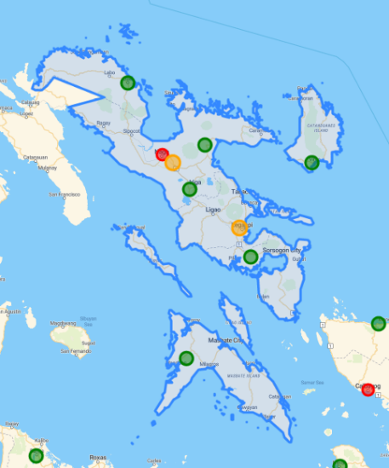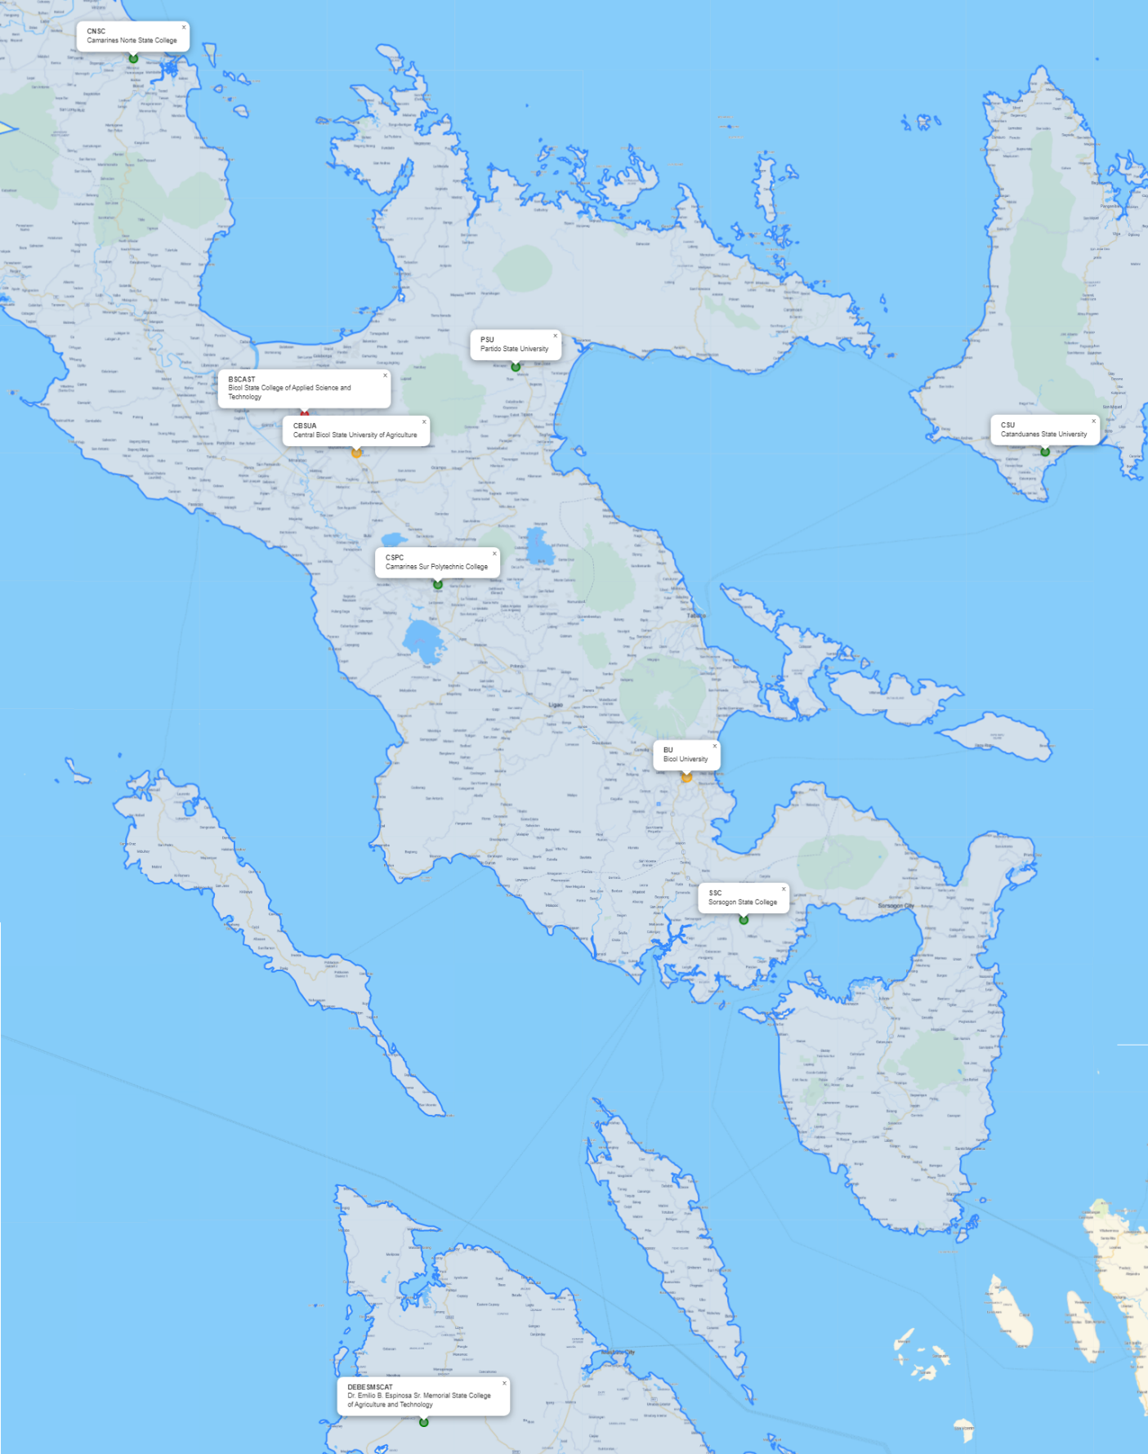**Bicol Region (Region V)**

SUC:

1. Camarines Norte State College (14.1090, 122.9562)
2. Partido State University (13.6974, 123.4825)
3. Bicol State College of Applied Science and Technology (13.6332, 123.1918)
4. Central Bicol State University of Agriculture (13.5825, 123.2630)
5. Catanduanes State University (13.5836, 124.2104)
6. Camarines Sur Polytechnic College (13.4060, 123.3753)
7. Bicol University (13.1482, 123.7180)
8. Sorsogon State College (12.9572, 123.7957)
9. Dr. Emilio B. Espinosa Sr. Memorial State College of Agriculture and Technology (12.2820,123.3568)

**Western Visayas (Region VI)**

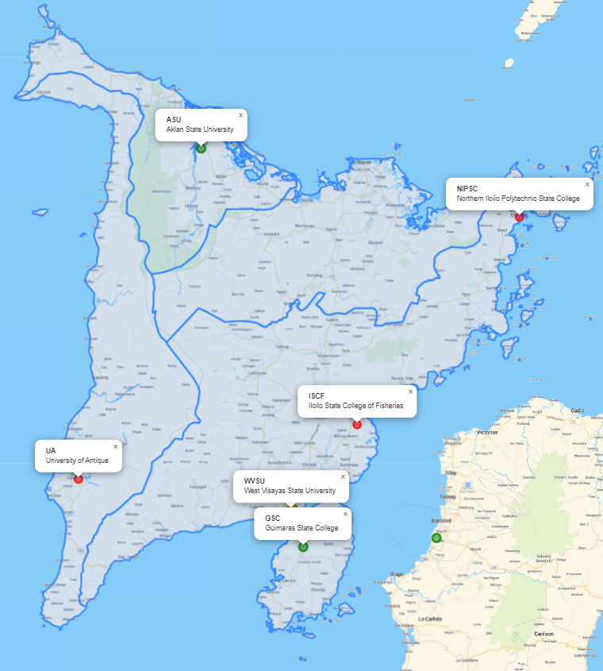

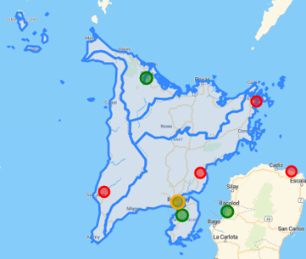

SUC:

1. Aklan State University (11.6331, 122.3292)
2. Northern Iloilo Polytechnic State College (11.4588, 123.1557)
3. Iloilo State College of Fisheries (10.9305, 122.7334)
4. University of Antique (10.7914, 122.0094)
5. West Visayas State University (10.7137, 122.5624)
6. Iloilo Science and Technology University (10.7154, 122.5663)
7. Guimaras State College (10.6188, 122.5941)

**Central Visayas (Region VII)**

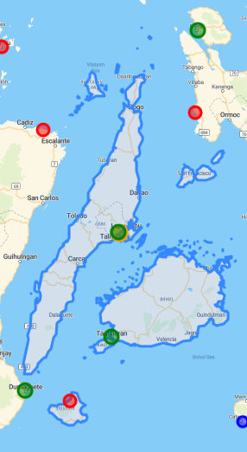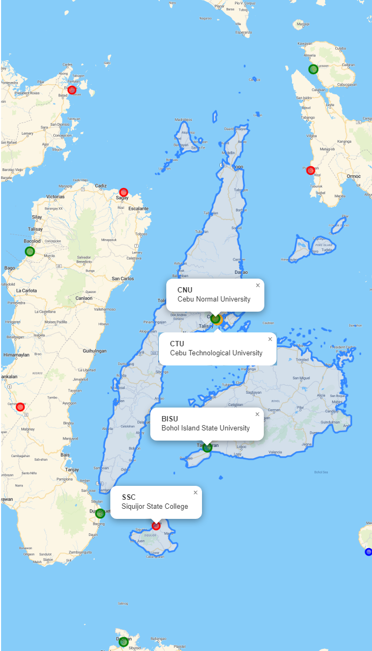

SUC:

1. Cebu Normal University (10.3017, 123.8967)
2. Cebu Technological University (10.2967, 123.9065)
3. Bohol Island State University (9.6477, 123.8554)
4. Siquijor State College (9.2496, 123.5899)

**Eastern Visayas (Region VIII)**

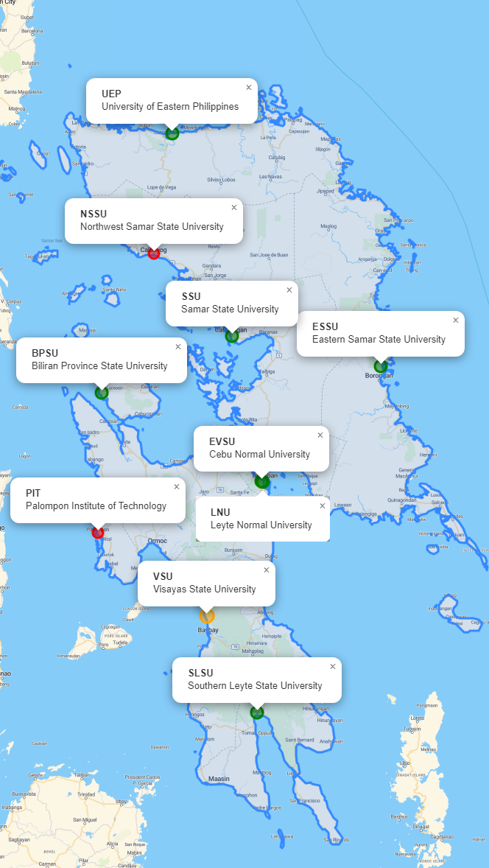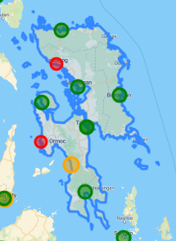

SUC:

1. University of Eastern Philippines (12.5094, 124.6648)
2. Northwest Samar State University (12.0711, 124.5968)
3. Samar State University (11.7711, 124.8859)
4. Eastern Samar State University (11.6604, 125.4424)
5. Biliran Province State University (11.5634, 124.4013)
6. Eastern Visayas State University (11.2402, 124.9974)
7. Leyte Normal University (11.2382, 125.0013)
8. Palompon Institute of Technology (11.0515, 124.3873)
9. Visayas State University (10.7460, 124.7946)
10. Southern Leyte State University (10.3920, 124.9799)

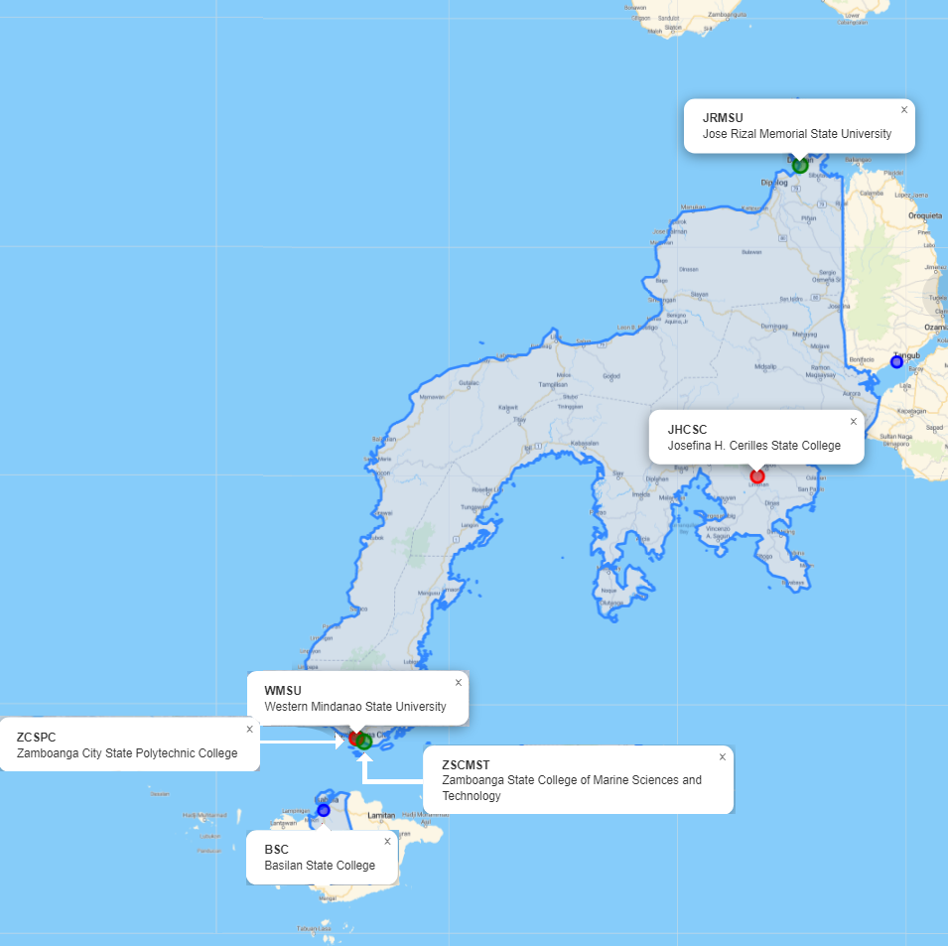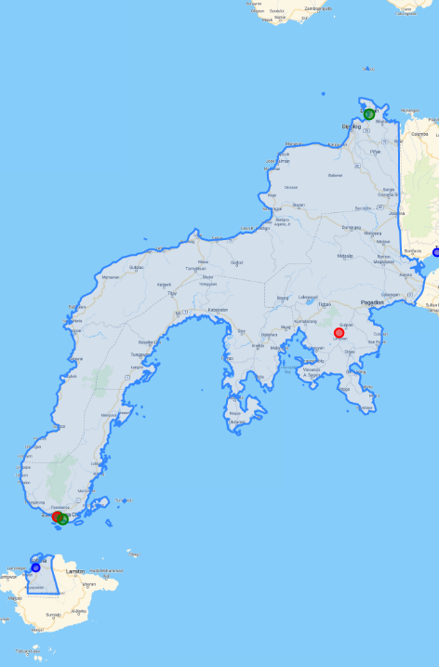**Zamboanga Peninsula (Region IX)**

SUC:

1. Jose Rizal Memorial State University (8.6559, 123.4226)
2. Josefina H. Cerilles State College (7.7100, 123.2908)
3. Western Mindanao State University (6.9136, 122.0614)
4. Zamboanga City State Polytechnic College (6.9128, 122.0591)
5. Zamboanga State College of Marine Sciences and Technology (6.9008, 122.0835)
6. Basilan State College (6.6920, 121.9612)

**Northern Mindanao (Region X)**

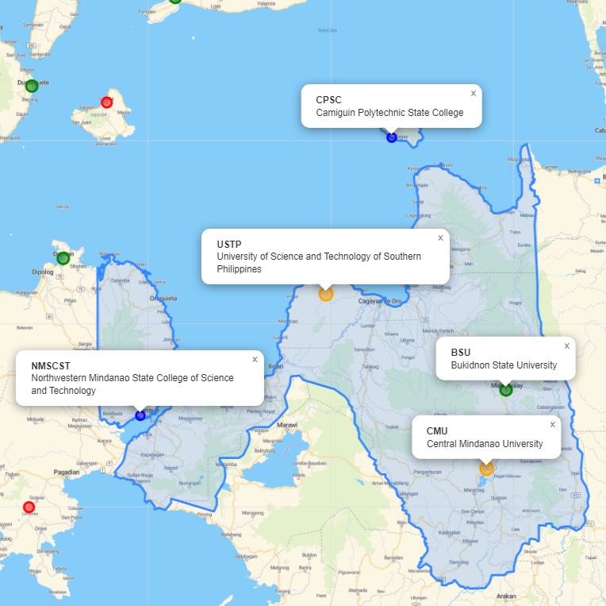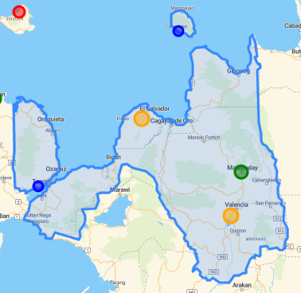

SUC:

1. Camiguin Polytechnic State College (9.1168, 124.6878)
2. University of Science and Technology of Southern Philippines (8.5223, 124.4340)
3. Bukidnon State University (8.1574, 125.1249)
4. Northwestern Mindanao State College of Science and Technology (8.0588, 123.7210)
5. Central Mindanao University (7.8592, 125.0515)

**Davao Region (Region XI)**

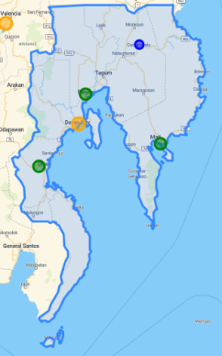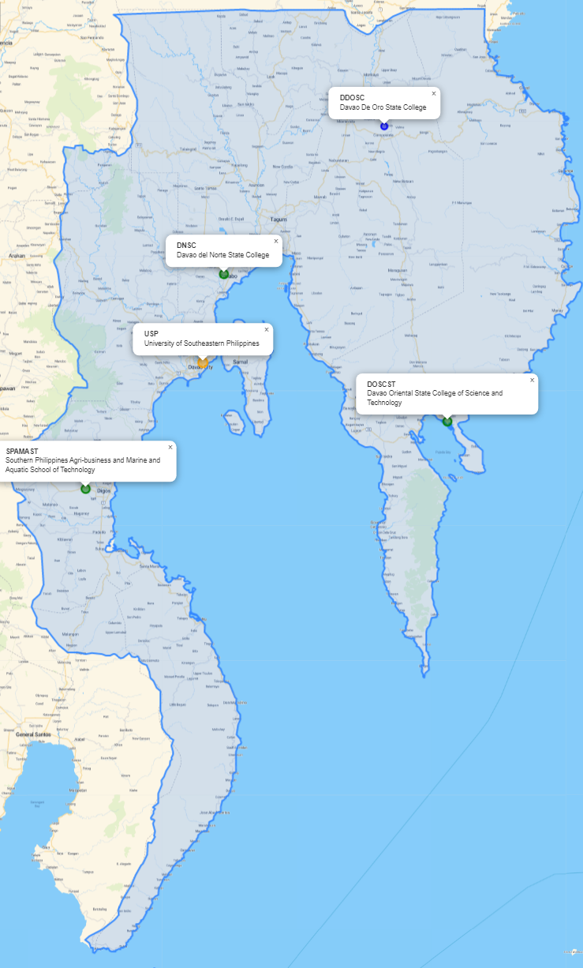

SUC:

1. Davao De Oro State College (7.6969, 126.0891)
2. Davao del Norte State College (7.3143, 125.6702)
3. University of Southeastern Philippines (7.0862, 125.6156)
4. Davao Oriental State College of Science and Technology (6.9333, 126.2535)
5. Southern Philippines Agri-business and Marine and Aquatic School of Technology (6.7593,125.3093)

**SOCCSKSARGEN (Region XII)**

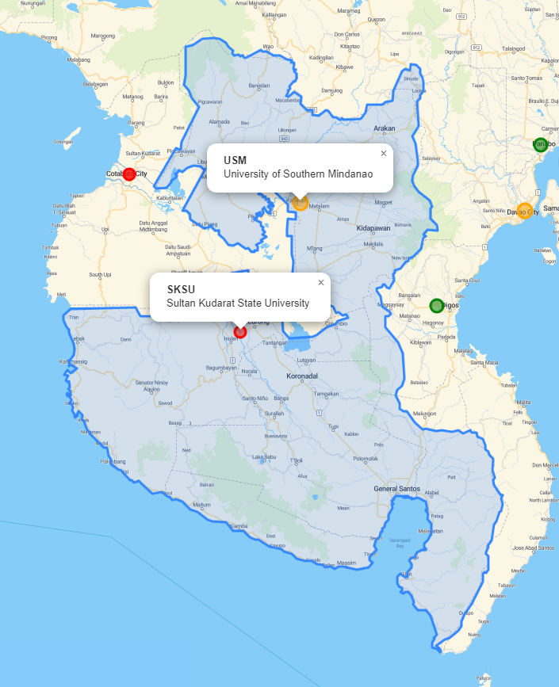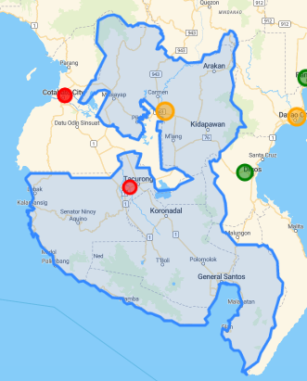

SUC:

1. University of Southern Mindanao (7.1154, 124.8367)
2. Sultan Kudarat State University (6.6693, 124.6297)

**Caraga (Region XIII)**

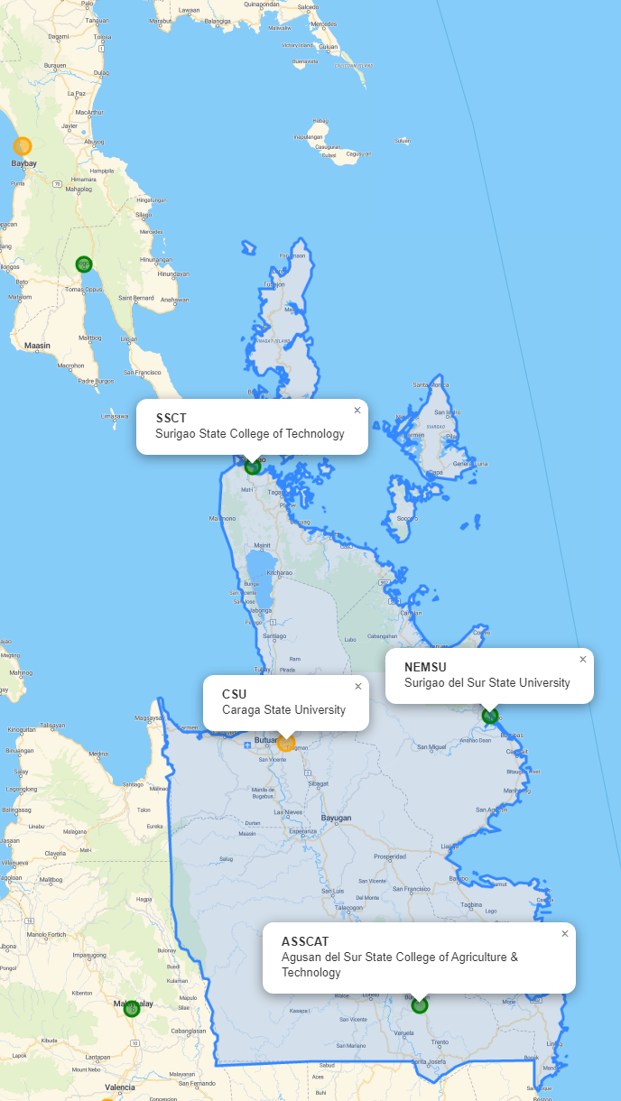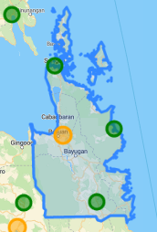

SUC:

1. Surigao State College of Technology (9.7876, 125.4947)
2. Surigao del Sur State University (9.0395, 126.2160)
3. Caraga State University (8.9586, 125.5958)
4. Agusan del Sur College of Agriculture & Technology (8.1693, 126.0035)

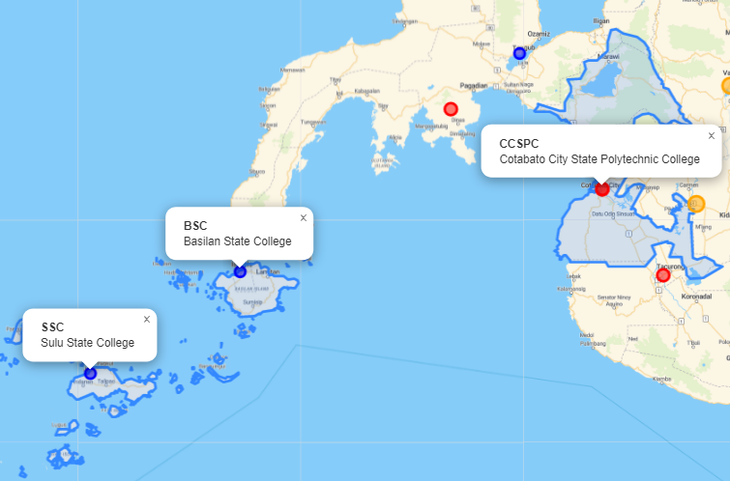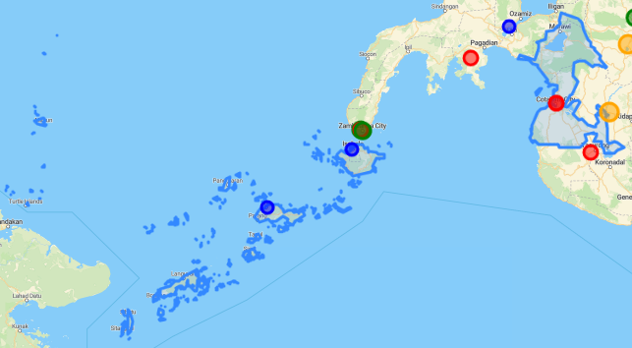**Bangsamoro Autonomous Region of Muslim Mindanao (ARMM)**

SUC:

1. Cotabato City State Polytechnic College (7.2115, 124.2441)
2. Cotabato Foundation College of Science and Technology (7.2115, 124.2442)
3. Basilan State College (6.6920, 121.9612)
4. Sulu State College (6.0507, 121.0128)

Negros Island Region (NIR)

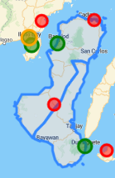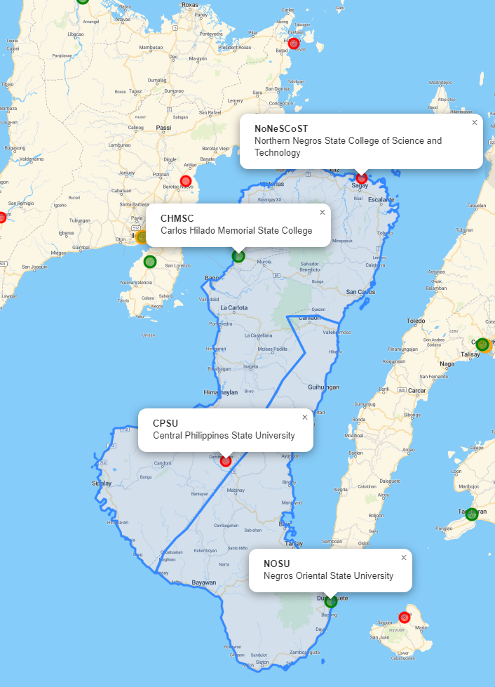

SUC:

1. Northern Negros State College of Science and Technology (10.9414, 123.4231)
2. Carlos Hilado Memorial State College (10.6418, 122.9395)
3. Central Philippines State University (9.8526, 122.8903)
4. Negros Oriental State University (9.3118, 123.3034)